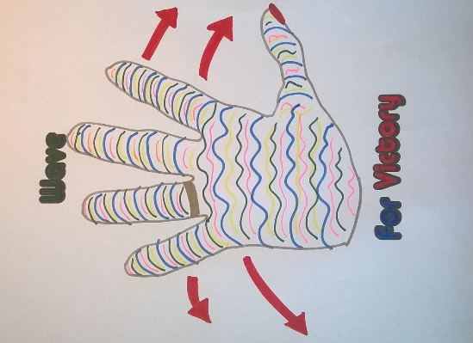
Wave for Victory

When John Muir left Glasgow on the ship that took him on his Voyage of Discovery, he might have waved to people on the dock.
John ended up doing a very important job-setting up The National Parks.
We have a very important job to do now too!
We have to remember to keep a safe distance from one another.
That way we will beat the virus!
Let's remind everyone to Wave for Victory!
Draw around your hand and decorate it any way you want
Put it in your window.
You can wave to key workers as they go passed.
They might wave back?!
If you prefer, you can draw:
a rainbow
a flower
a smiley face

